**Mini Shop App using Windows Forms**

**(Short Description)** I used 2 different forms, the 1st one is a login form when I run the program that reads the user and password from a txt file and when the correct ones are entered the 2nd form opens, which has a Tab Control with 4 different tabs:

* A Home tab - contains an image and 2 buttons: one for closing the form and one that sends the user to the Shop tab.
* An Account tab – contains a list with all the orders placed in the Cart tab and the items for each one + suggests the inclusion of the gift bonus
* A Shop tab – contains a list of products that can be placed in an order in the cart by pressing the specific buttons
* A Cart tab – contains the chosen items in a list box, a label that calculates the total value of the respective order, a progress bar that fills at orders of 50$ or above and includes a bonus gift, 2 buttons (one for removing items from the list and one for placing the order) and a pop-up text box that confirms the order

I will list some screenshots below with important bits from the code:

**Form1**

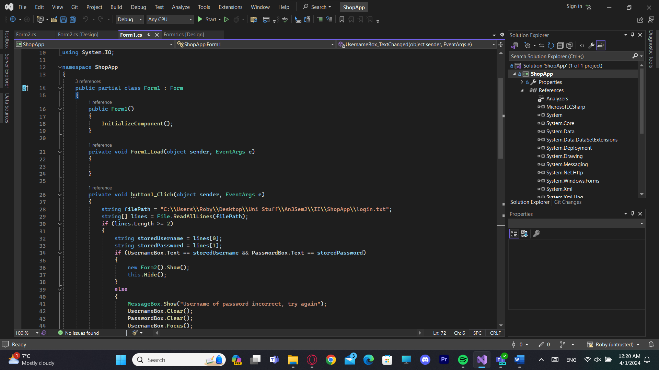

**Form2**

Tab1 (Home): Form + Code

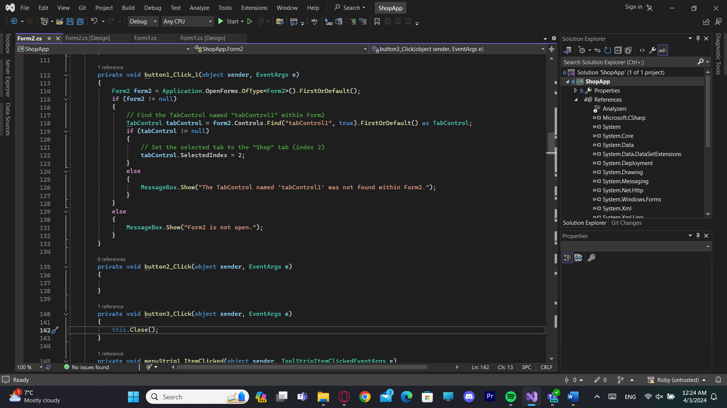

Tab2 (Account): Form + Code

Tab3 (Shop): Form + Code

Button4 is copy and pasted for 5, 6, 7.

Tab4 (Cart): Form + Code

CartItem + Order classes:

Calculating the total value of the order:

Progress bar + Cart listBox:

